# Assignment(Create and Manipulate DB Schema)

## Generate E-R ModelC:\Users\Admin\Downloads\WhatsApp Image 2022-10-17 at 10.33.57 PM.jpeg

* 1. **Insert records**
  + **Table-Department**

INSERT INTO `student_mangement_schema`.`department` VALUES ('1', 'CSE'); INSERT INTO `student_mangement_schema`.`department` VALUES ('2', 'ME'); INSERT INTO `student_mangement_schema`.`department` VALUES ('3', 'EEE');

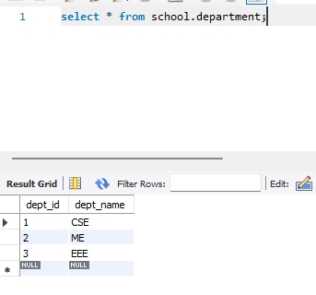

* **Table-Semester**

INSERT INTO `student_mangement_schema`.`semester` VALUES ('1', 'odd', '2021'); INSERT INTO `student_mangement_schema`.`semester` VALUES ('2', 'even', '2022'); INSERT INTO `student_mangement_schema`.`semester` VALUES ('3', 'odd', '2022');

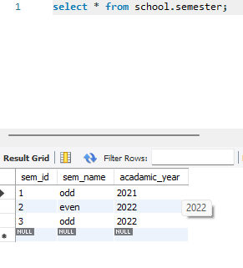

* + - * **Table-CourseDetails**

INSERT INTO `student_mangement_schema`.`course_details` VALUES ('101', 'JAVA', '1', '1', 'Core');

INSERT INTO `student_mangement_schema`.`course_details` VALUES ('102', 'CadLabs', '2', '2', 'Regular');

INSERT INTO `student_mangement_schema`.`course_details` VALUES ('103', 'DSA', '2', '3', 'Elective');

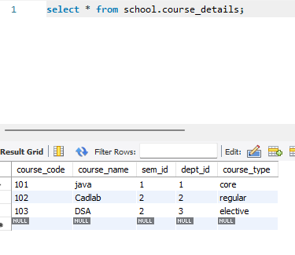

* + - * **Table-Staffs**

INSERT INTO `student_mangement_schema`.`staffs` VALUES ('1', 'Ankush ', 'Gaba', 'Associate ', '2021', '1999-08-08', '1', '2021-09-12', '3', '10000');

INSERT INTO `student_mangement_schema`.`staffs` VALUES ('2', 'Reena', 'Dhingra', 'Professor', '2018', '1998-07-23', '3', '2022-04-23', '5', '150000');

INSERT INTO `student_mangement_schema`.`staffs` VALUES ('3', 'Ram', 'Singh', 'Director', '2019', '1975-02-21', '2', '2015-07-22', '12', '250000');

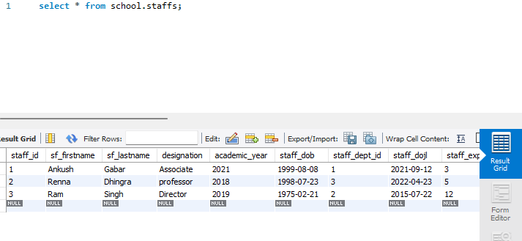

* + - * **Table-Staffs**

INSERT INTO `student_mangement_schema`.`staffs` VALUES ('1', 'Ankush ', 'Gaba', 'Associate ', '2021', '1999-08-08', '1', '2021-09-12', '3', '10000');

INSERT INTO `student_mangement_schema`.`staffs` VALUES ('2', 'Reena', 'Dhingra', 'Professor', '2018', '1998-07-23', '3', '2022-04-23', '5', '150000');

INSERT INTO `student_mangement_schema`.`staffs` VALUES ('3', 'Ram', 'Singh', 'Director', '2019', '1975-02-21', '2', '2015-07-22', '12', '250000');



* **Table-Result_analysis**

INSERT INTO `student_mangement_schema`.`result_analysis` VALUES ('101', '33', '1');

INSERT INTO `student_mangement_schema`.`result_analysis` VALUES ('102', '34', '2');

INSERT INTO `student_mangement_schema`.`result_analysis` VALUES ('103', '35', '3');

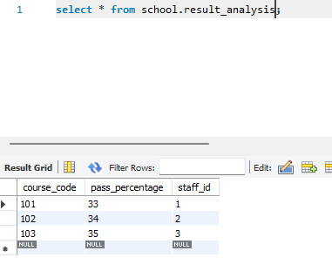

* + - * **Table-Student**

INSERT INTO `student_mangement_schema`.`students` VALUES ('1', 'Sohan', 'Sharma', '1996-08-18', '2021-07-28', '1', 'panipat', '132103', '1');

INSERT INTO `student_mangement_schema`.`students` VALUES ('2', 'Mohan', 'Dhingra', '1997-02-23', '2021-08-06', '2', 'Karnal', '132119', '2');

INSERT INTO `student_mangement_schema`.`students` VALUES ('3', 'Rohan', 'Verma', '1998-09-06', '2021-09-09', '3', 'Samalkha', '132101', '1');

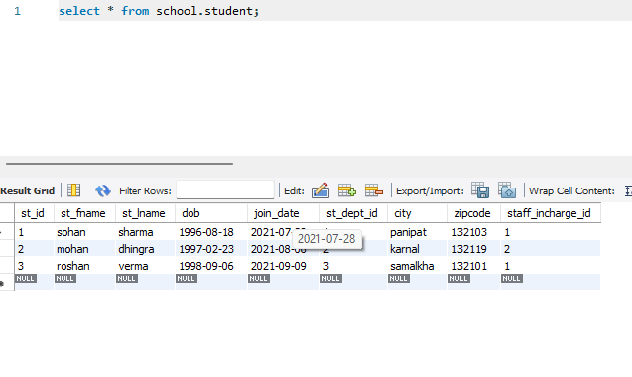

* + - * **Table-student_Marks**

INSERT INTO `student_mangement_schema`.`student_marks` VALUES ('1', '1', '101', '47', '102', '68',

'103', '45', '50');

INSERT INTO `student_mangement_schema`.`student_marks` VALUES ('2', '2', '102', '78', '103', '78',

'101', '64', '69');

INSERT INTO `student_mangement_schema`.`student_marks` VALUES ('3', '3', '103', '89', '102', '76',

'101', '76', '77');

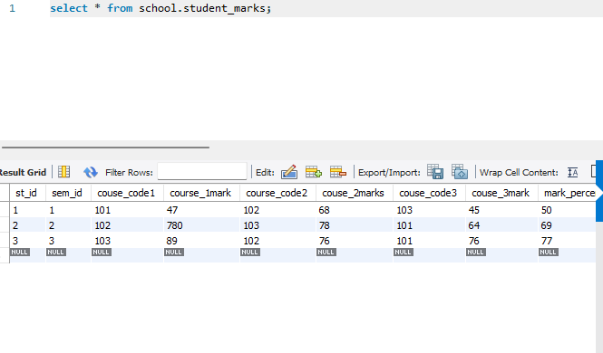

* 1. **Create view vw_placement with appropriate constraints data type, marks colum should only accept if the marks>80**

create view placement as

select s.st_id, s.st_fname, s.st_dept_id, m.marks_percentage as marks from students as s INNER JOIN student_marks as m ON s.st_id=m.st_id

where m.marks_percentage >80 ;

**Output**

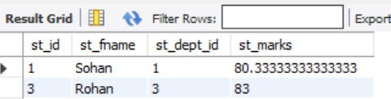

* 1. **Caluclate the marks_percentage in student_marks and update it respectively**

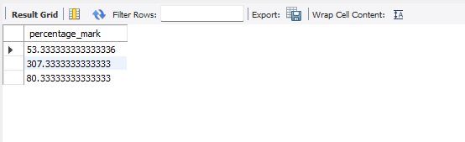

* 1. **Add new Staff_id in course_details and insert value respectively**

